Exp No:10
Date:20.08.2026
Internetworking with routers in CISCO PACKET TRACER
simulator.

AIM:-a) Internetworking with routers in CISCO PACKET TRACER simulator.

Step-1
Design and configure a simple internetwork using a router.

Step-2
1. Assign IP Addresses to every PC in the network.
2. Select the PC, Go to the desktop and select IP Configuration and assign an IP address, Default gateway, Subnet Mask
3. Assign the default gateway of PC0 as 192.168.10.1.
4. Assign the default gateway of PC1 as 192.168.20.1.
Step-3(Connecting PCs with Router):
1. Connect FastEthernet0 port of PC0 with FastEthernet0/0 port of Router1 using a copper straight-through cable.
2. Connect FastEthernet0 port of PC1 with FastEthernet0/1 port of Router1 using a copper straight-through cable.
Router Configuration Table:

Device Name | IP address FastEthernet0  /0 | Subnet Mask | IP Address FastEthernet0/1 | Subnet Mask
Router1 | 192.168.10.1 | 255.255.255.0 | 192.168.20.1 | 255.255.255.0
PC Configuration Table:
Device Name | IP address | Subnet Mask | Gateway
PC 0 | 192.168.10.2 | 255.255.255.0 | 192.168.10.1
PC 1 | 192.168.20.2 | 255.255.255.0 | 192.168.20.1

Output:

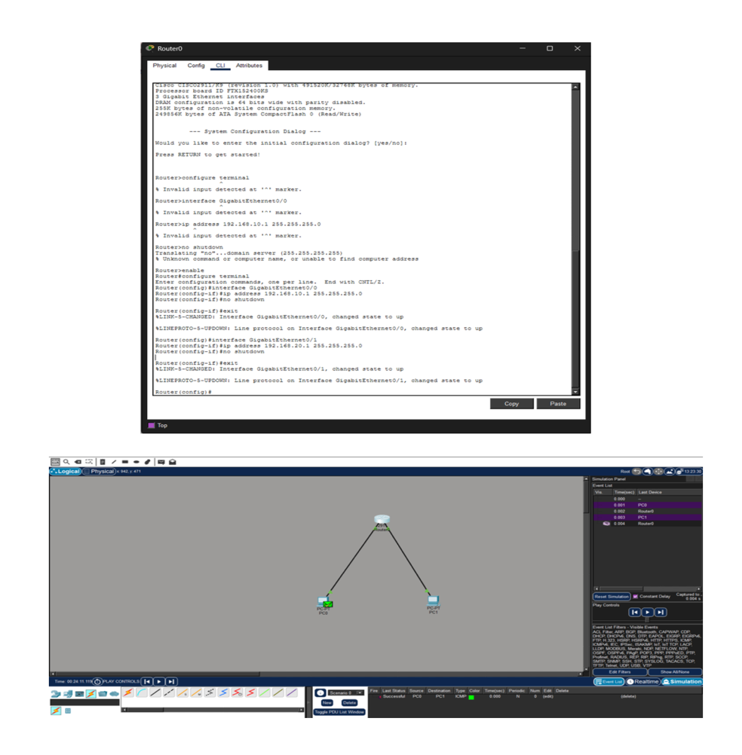

AIM:- b) Design and configure an internetwork using wireless router, DHCP server and internet cloud.

Addressing Table
Device | Interface | IP Address | Subnet Mask | Default Gateway
PC | Ethernet0 | DHCP |  | 192.168.0.1
Wireless Router | LAN | 192.168.0.1 | 255.255.255.0
Wireless Router | Internet | DHCP
Cisco.com Server | Ethernet0 | 208.67.220.220 | 255.255.255.0
Laptop | Wireless0 | DHCP
Objectives
Part 1: Build a Simple Network in the Logical Topology Workspace

Part 2: Configure the Network Devices Part 3: Test Connectivity between Network Devices Part 4: Save the File and Close Packet Tracer
